Click on file and Create a new soapui project

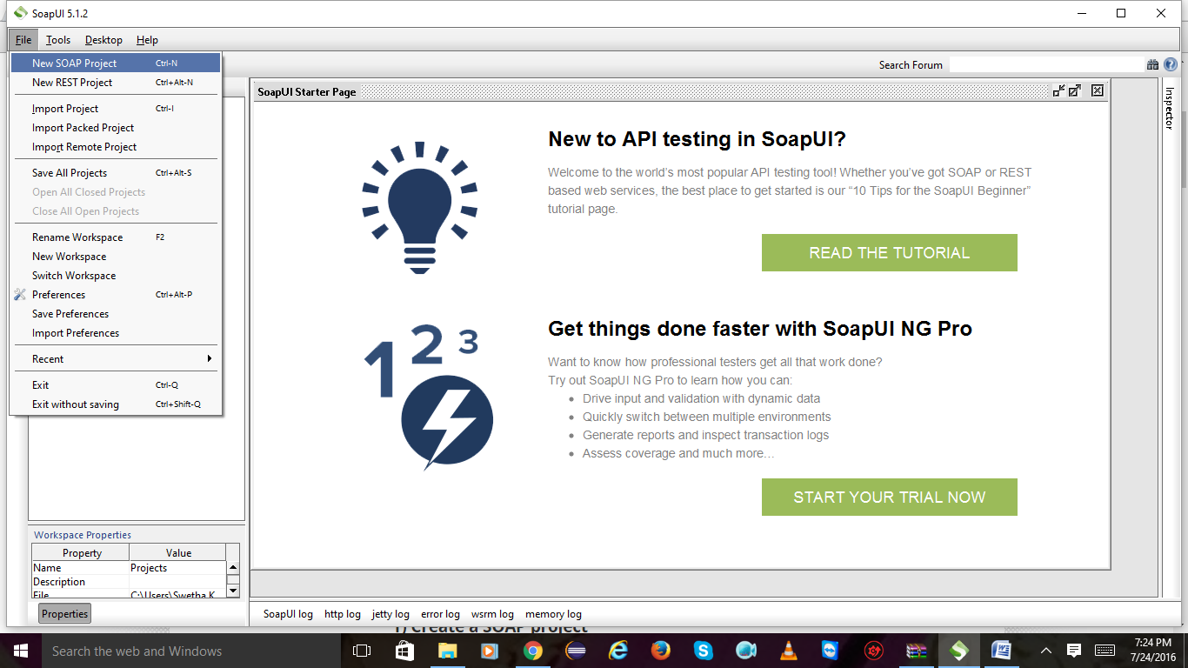

2) give project name and url and click on ok.

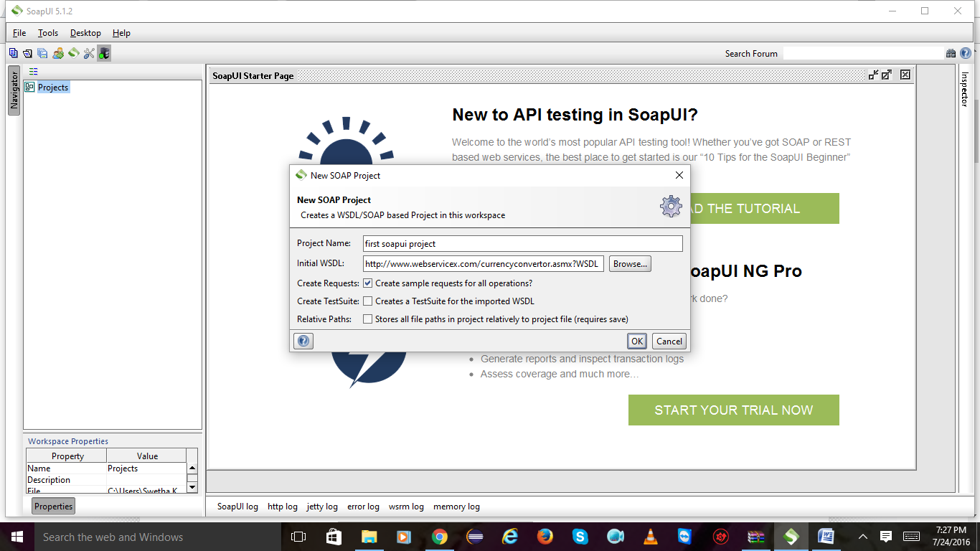

4) I have created a new project and adding a new test case for request

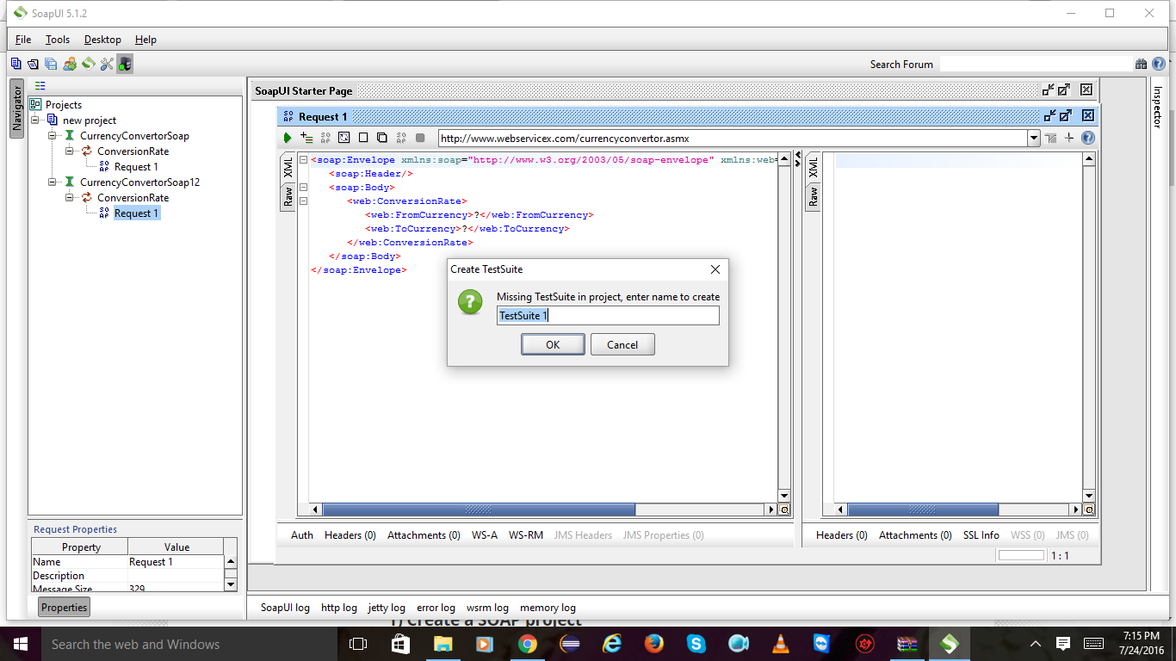

Click ok on test case

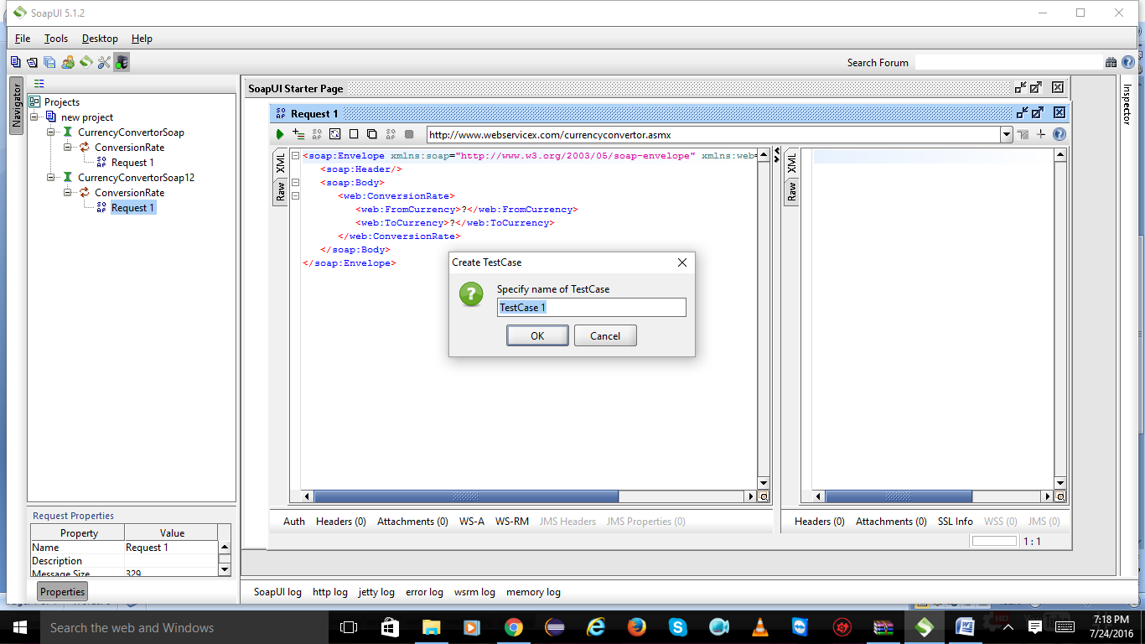

Click on ok

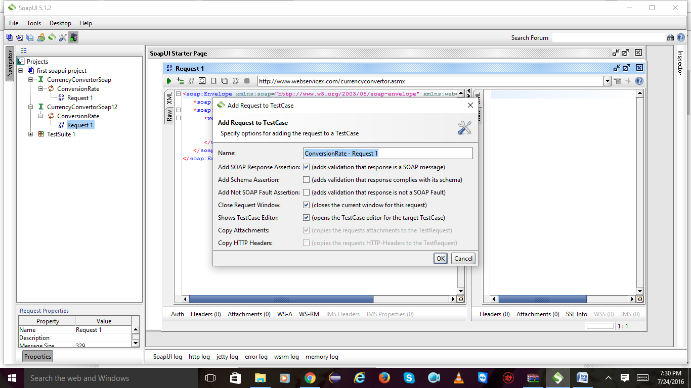

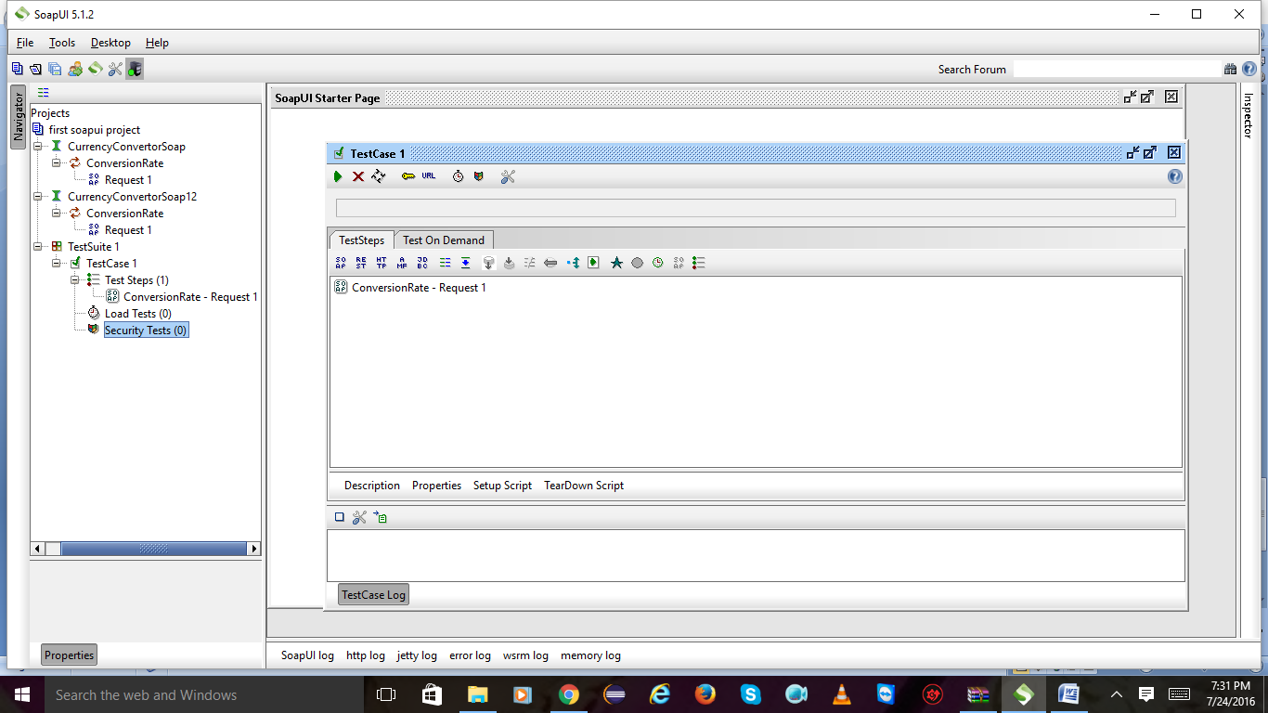

Click on assertion and click on icon left side and mark on hide description u will get 4 options select xpath match and click on add.

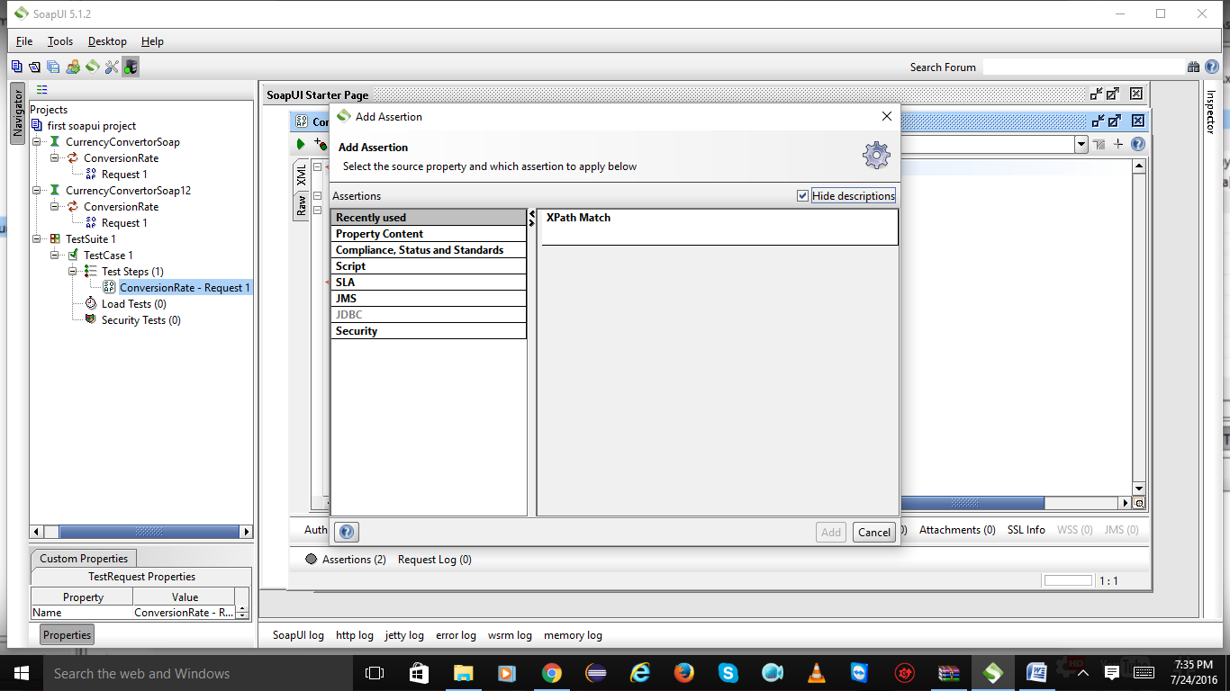

Click on ok

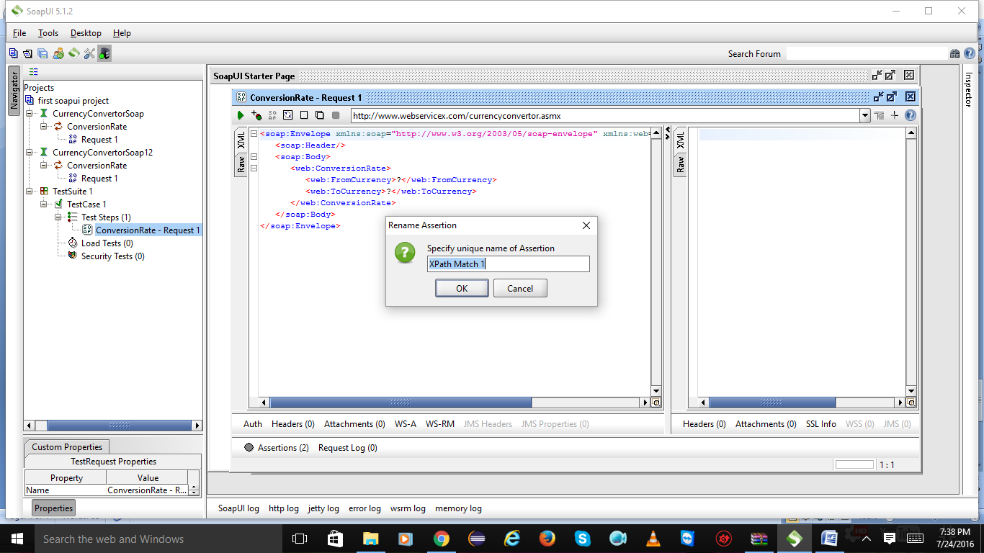

Click on declare u will get namespace to be add or not click on yes and save

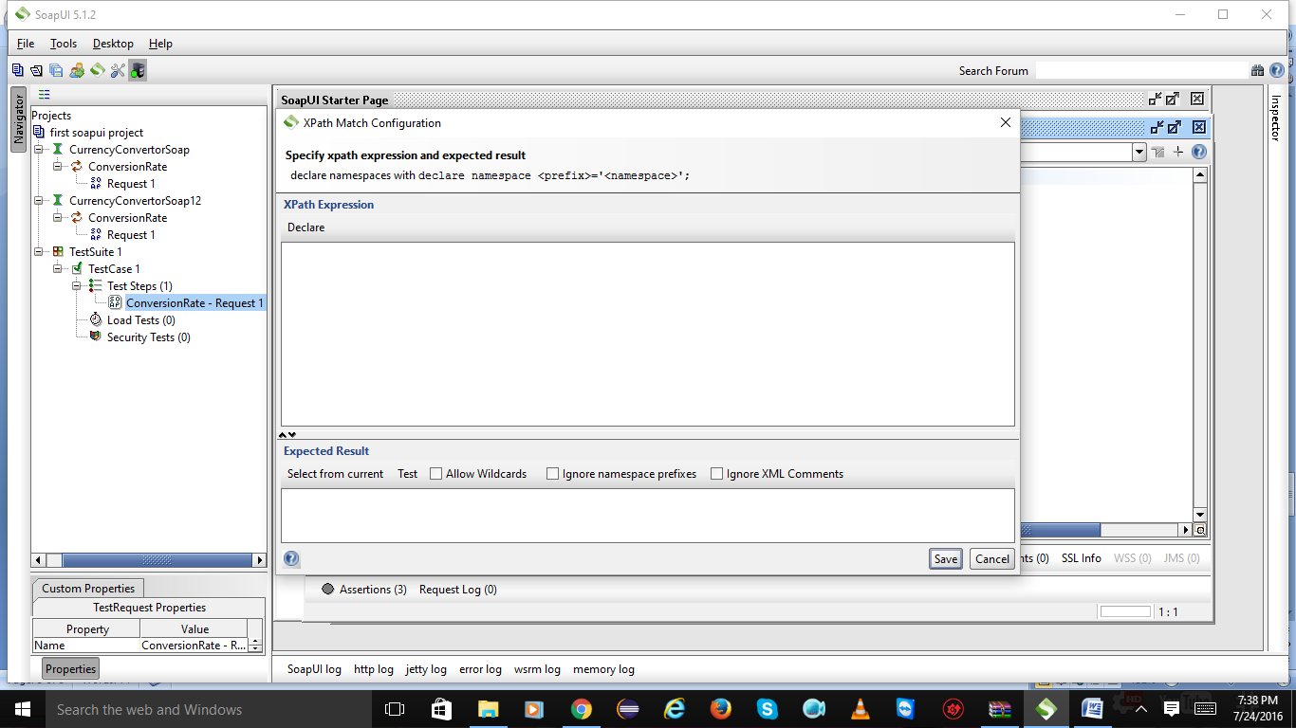

After saving choose

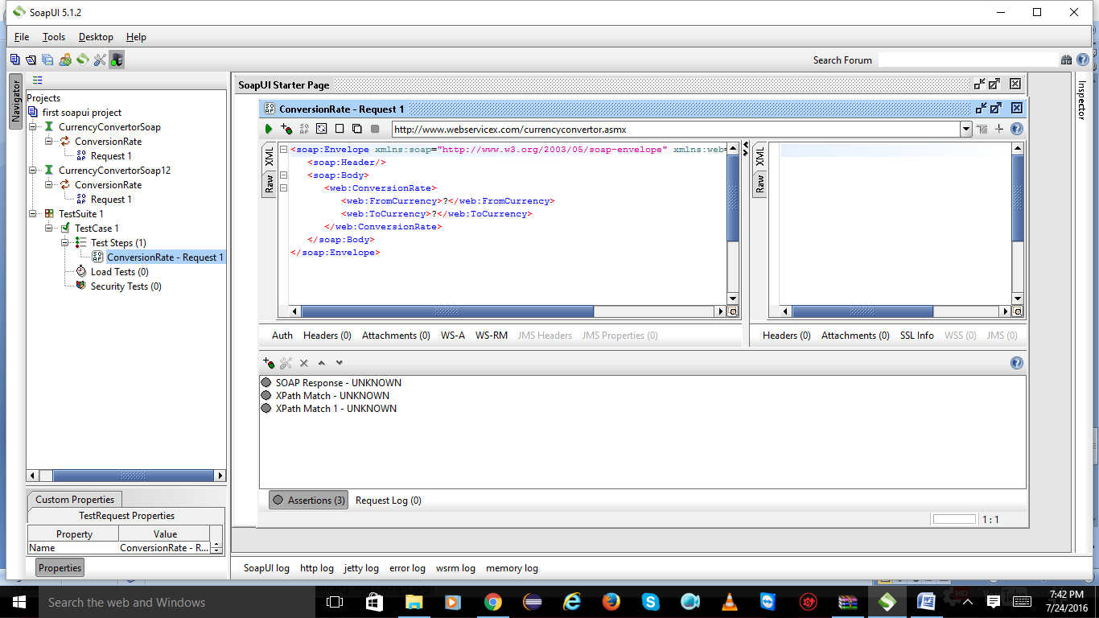

Click on test suite 1

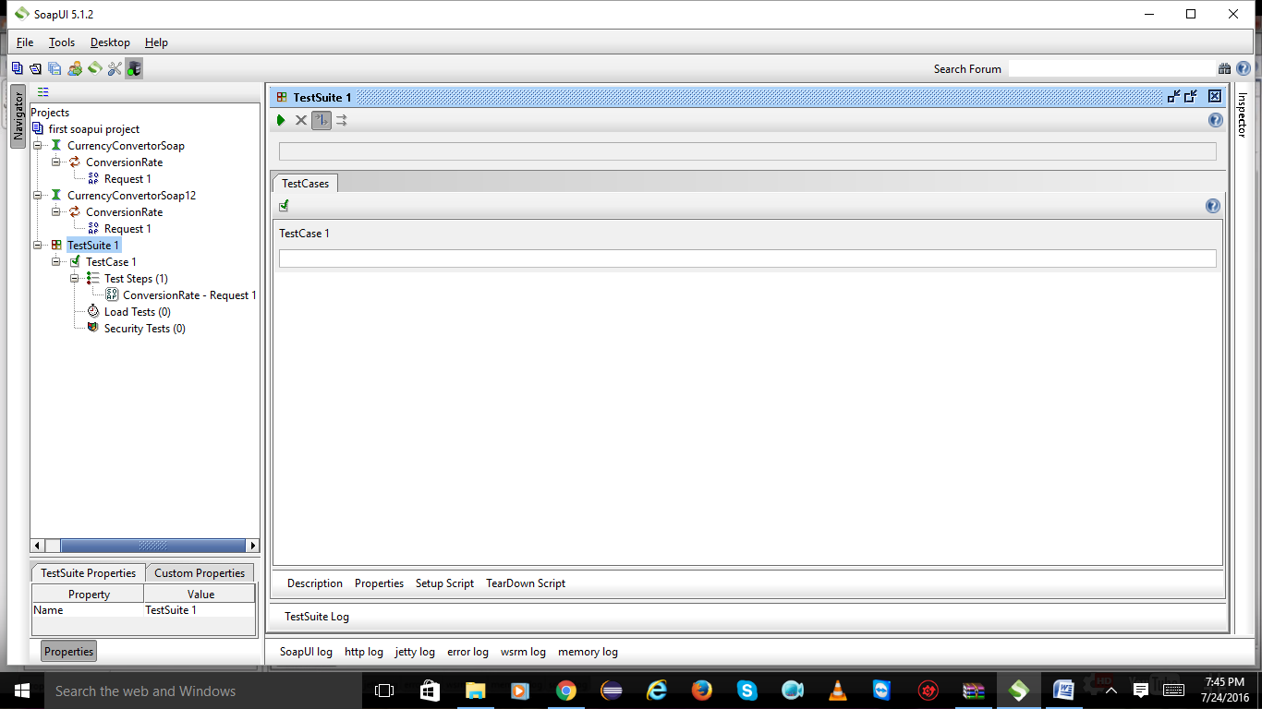

**Assertions:**

**Basic assertions:**

Add test case:

verify response returning true:

verify assertion not having null or false value:

verify response is valid soap response-soap assertion:

verify response have valid HTTP code:

verify that response time is with in boundaries:

verify security threat:

Right click on test suite and select new test case

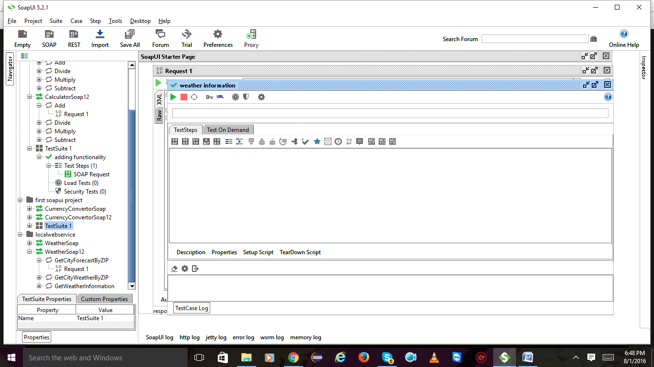

Expand test suite and also test case right on it and select add step in that again select soap request

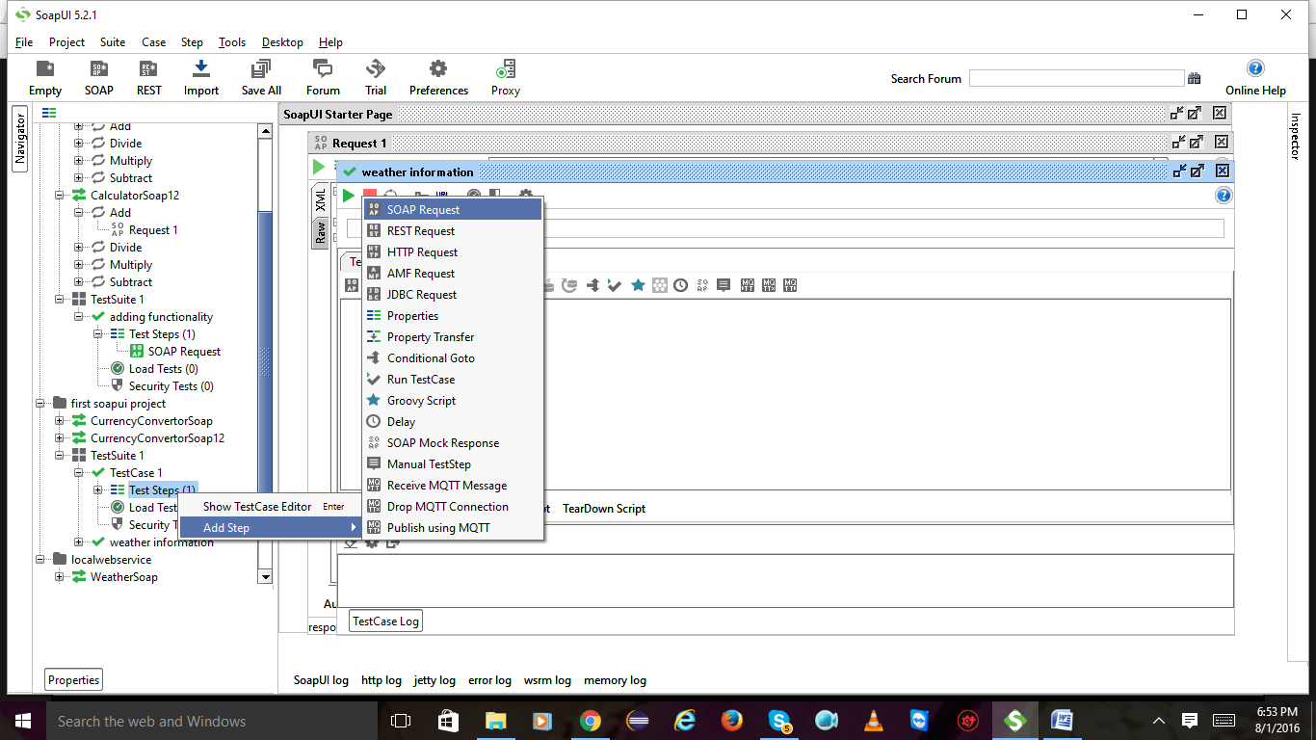

Click on ok

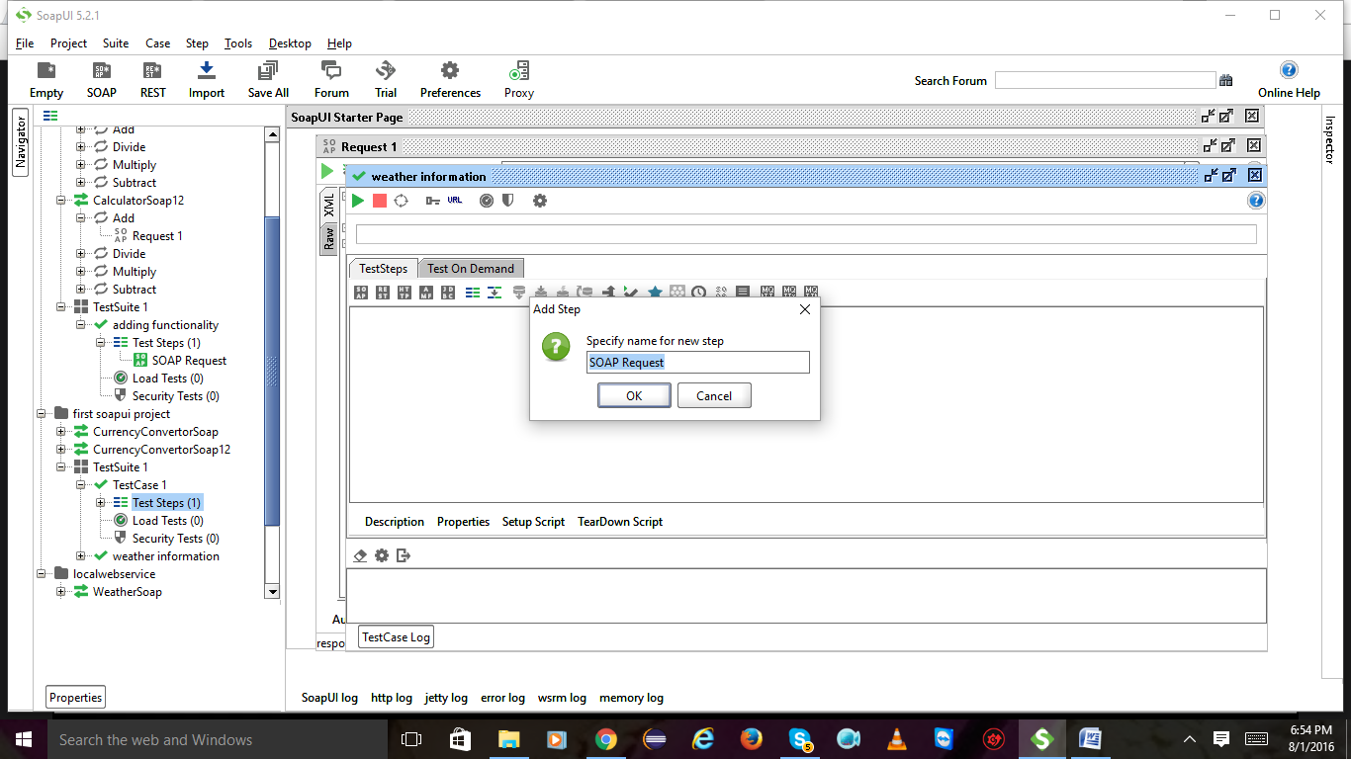

Click on ok

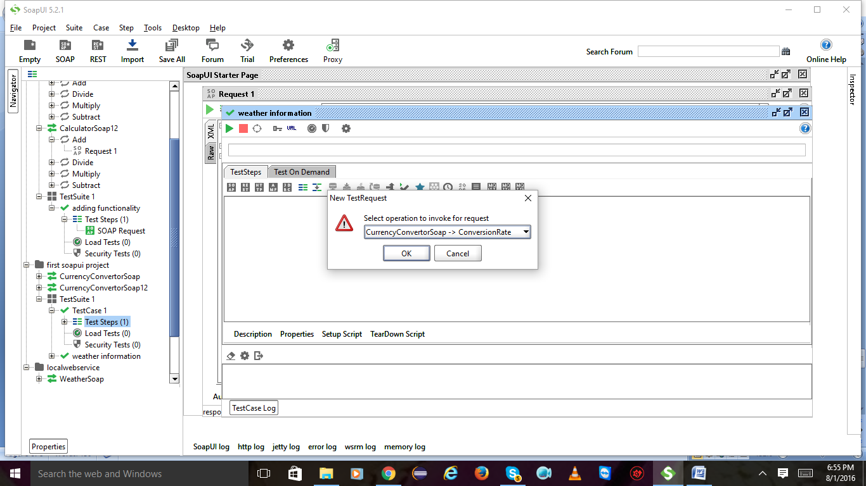

Click on ok

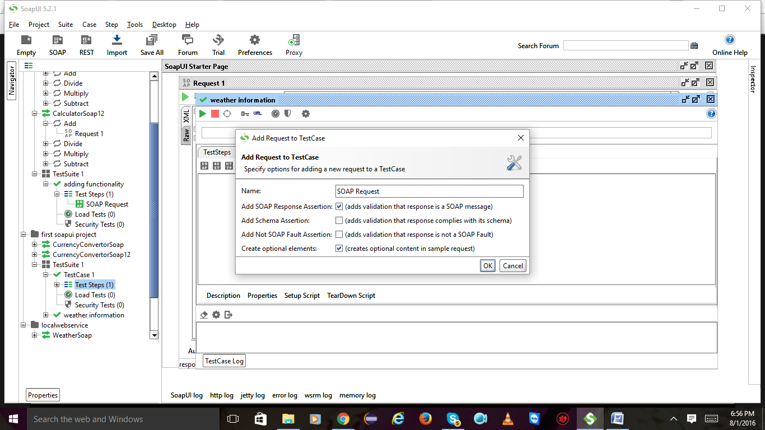

Now u will get into this page

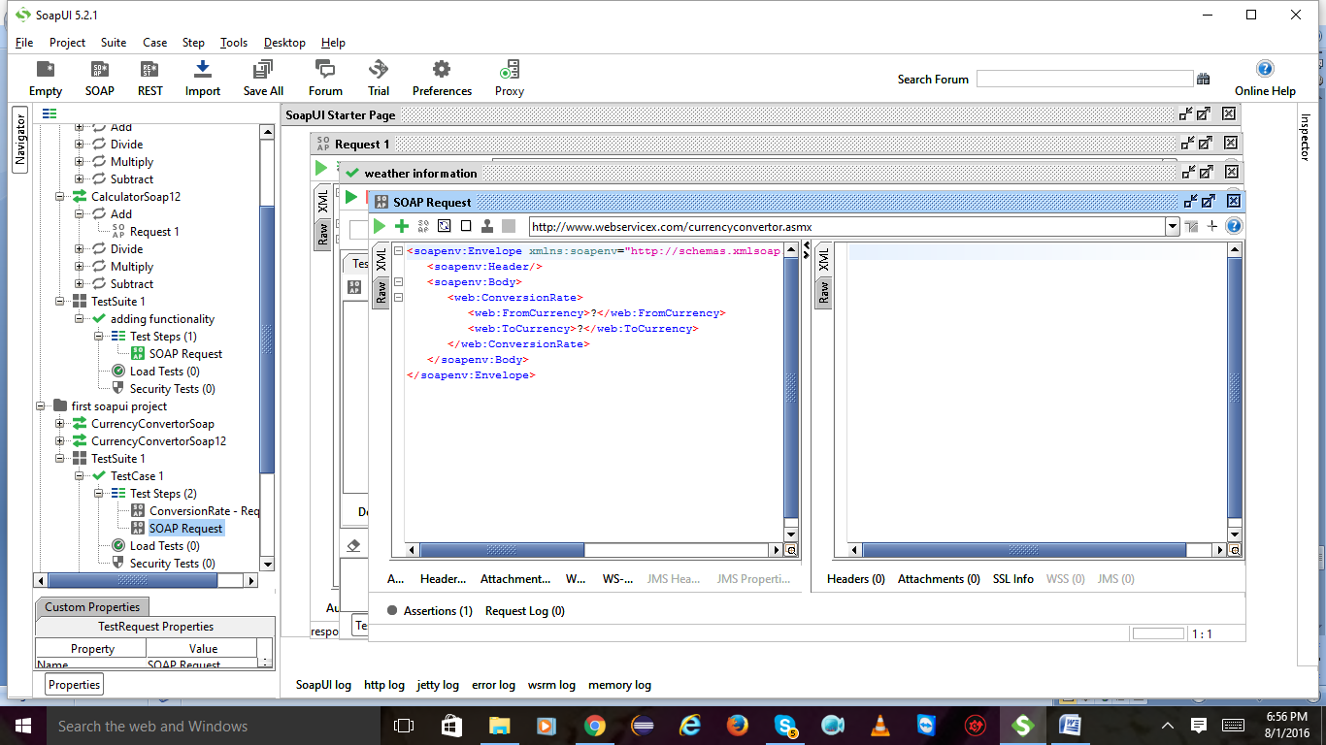

**verify response returning true:**

Give the parameters and hit on play button u will get the result on right side

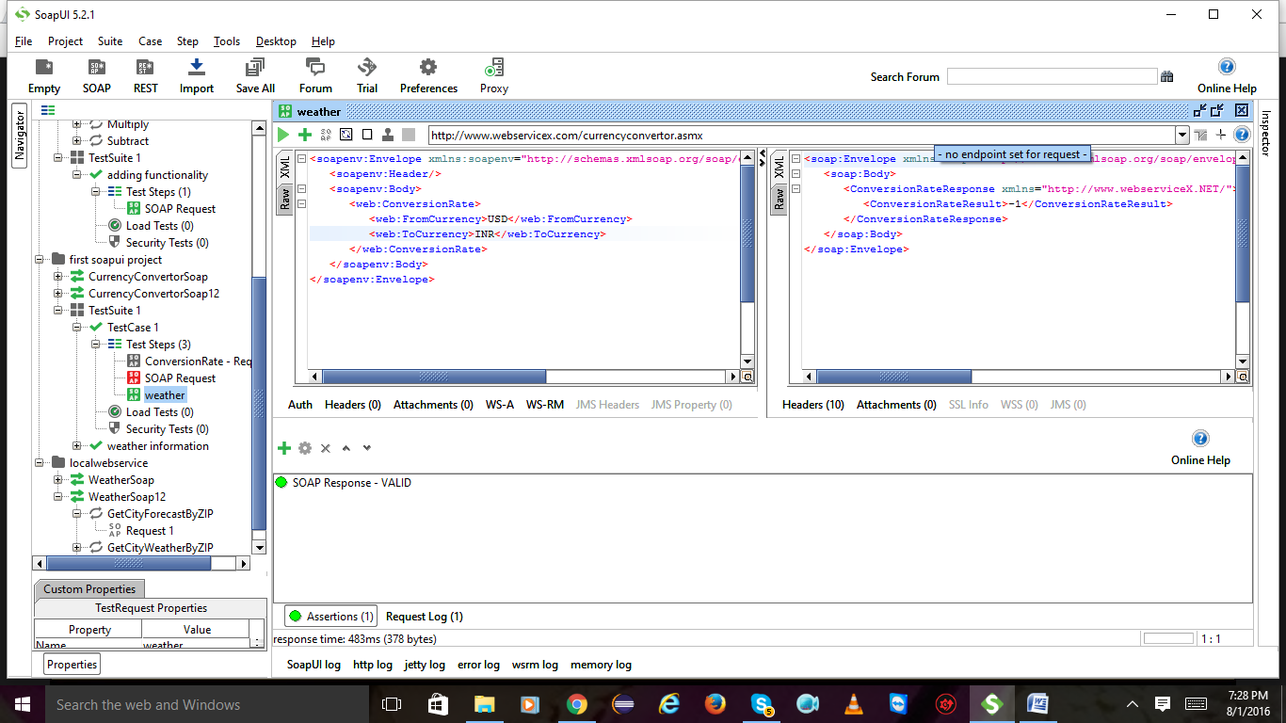

2)Click on plus symbol to add assertions and again click on contains

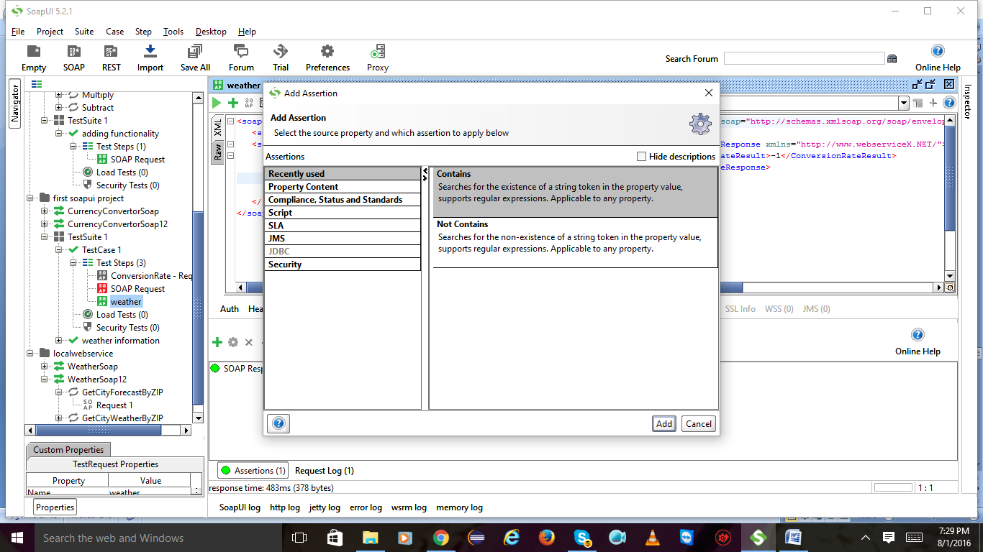

Type whatever u get in the previous result like true or false.after giving it will checks that it is matching with the previous result or not.if yes the test is successful.

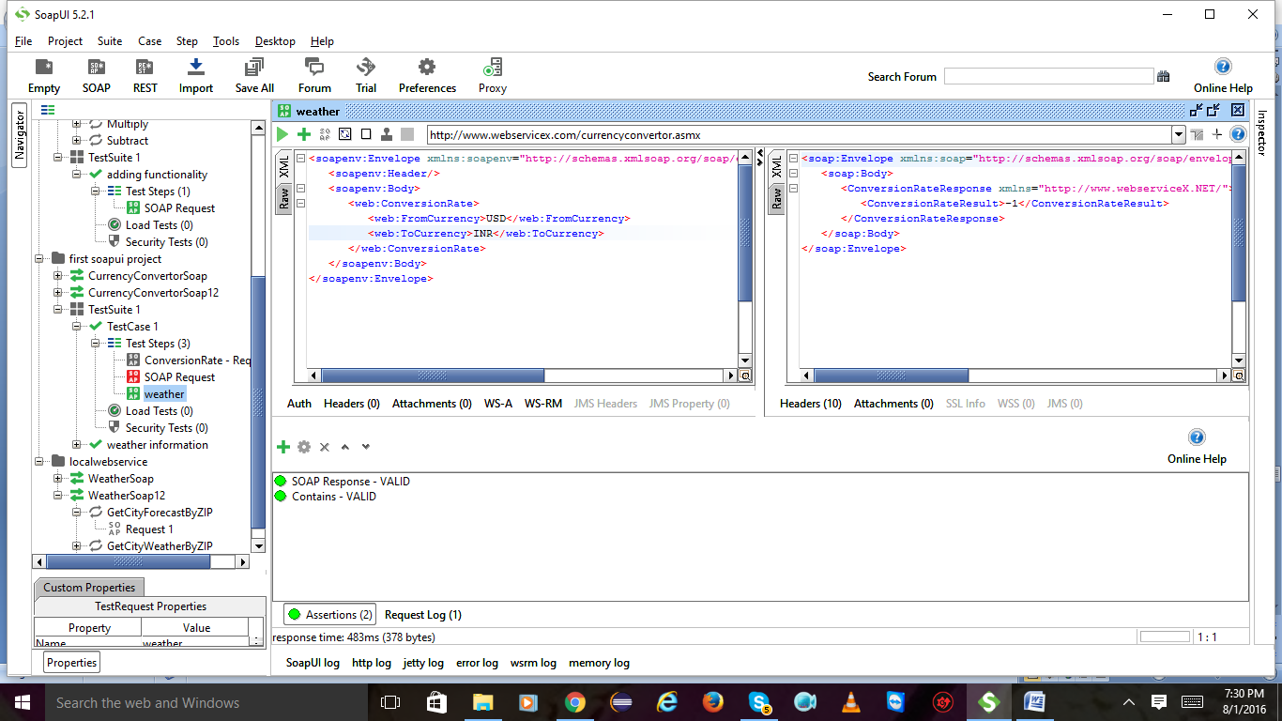

Assertion is **valid**



Add another assertion and select property content and select not contains

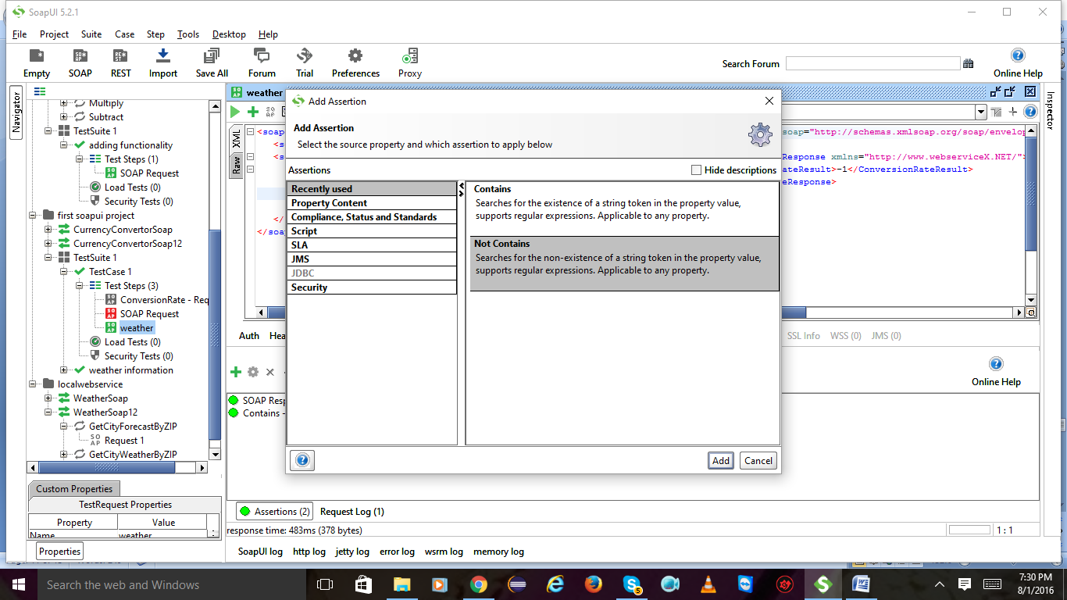

Give opposite result of previous result and click on ok

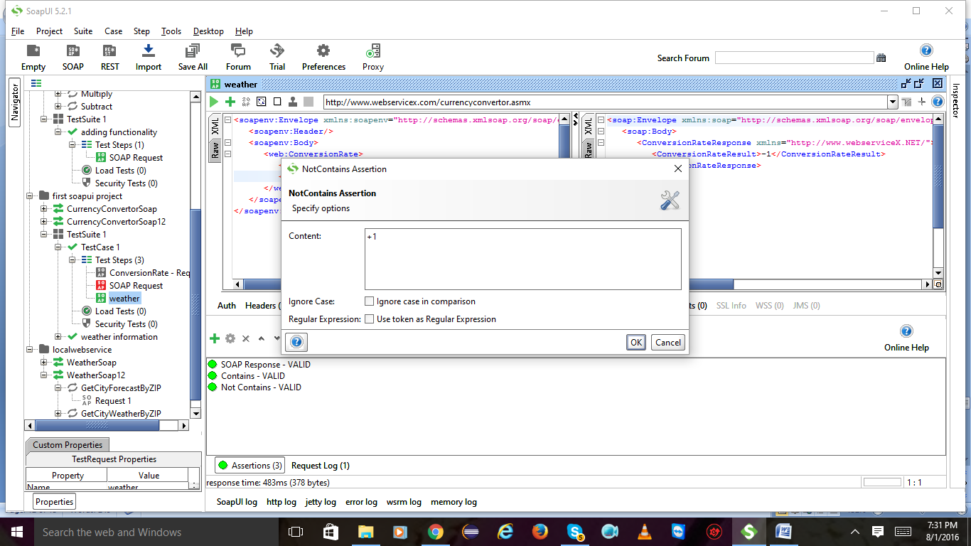

Now you will get the **not contains** assertion is **valid**

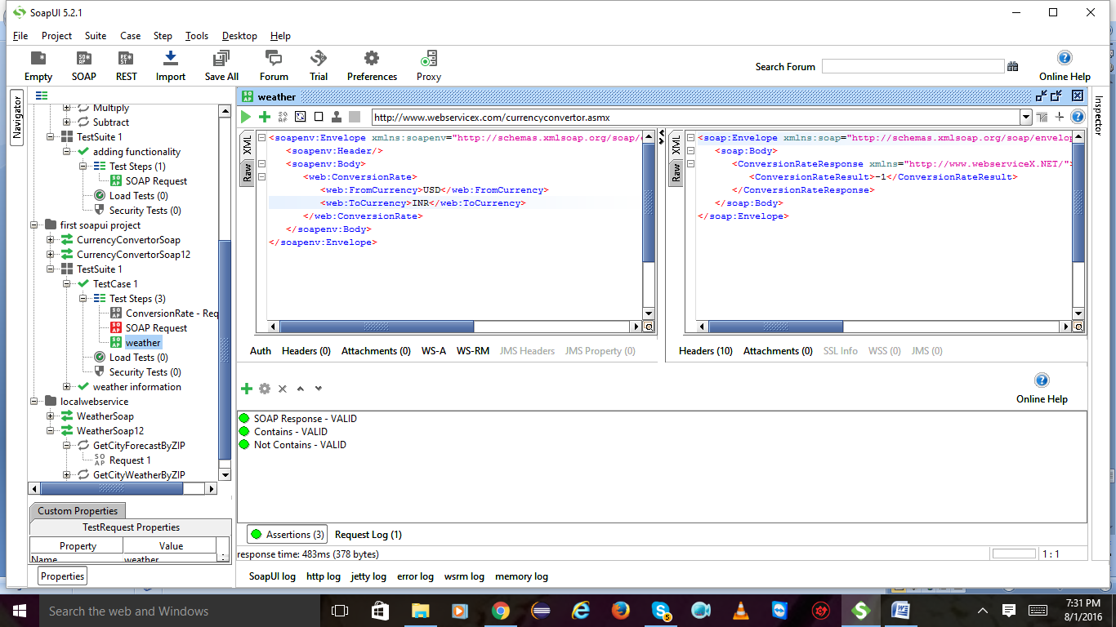

Add assertion and select compliance in that soap response double click on it

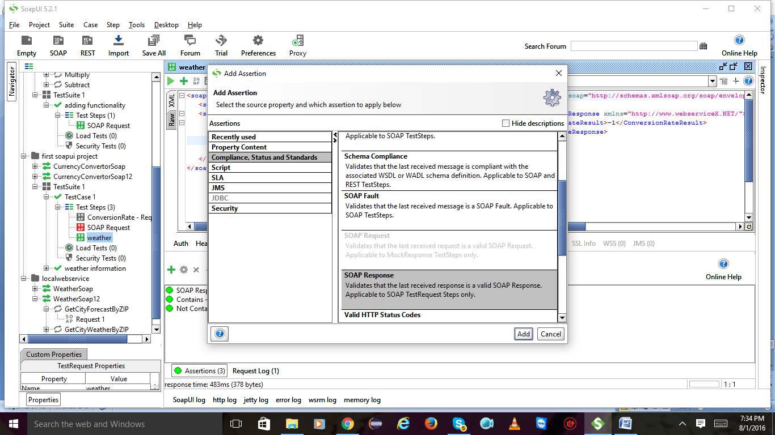

Remove soap response and add again

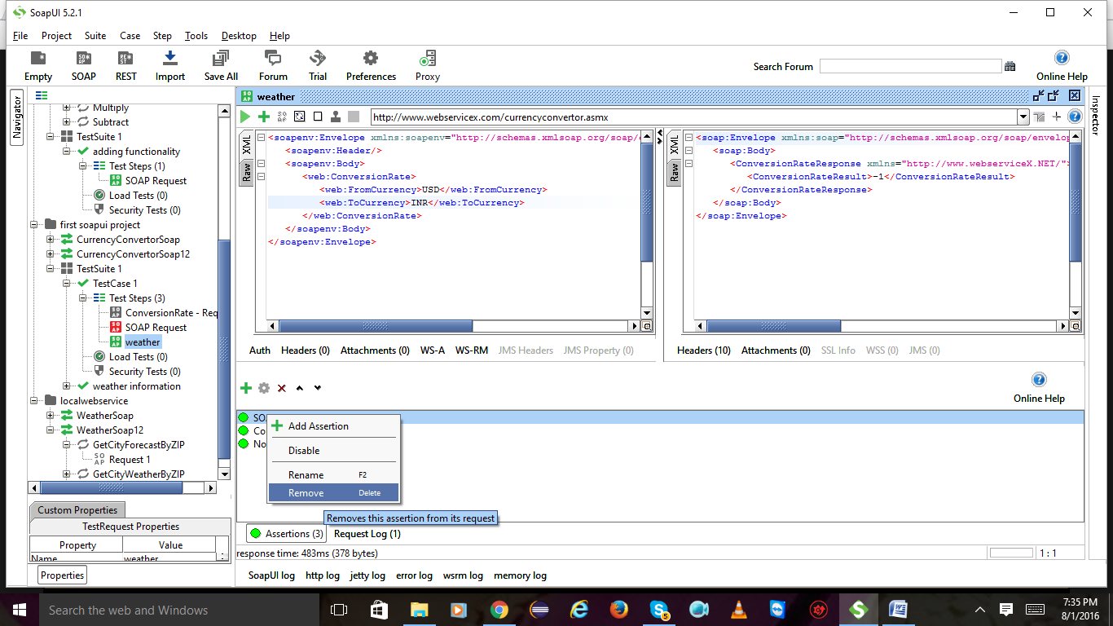

Again I have added soap response

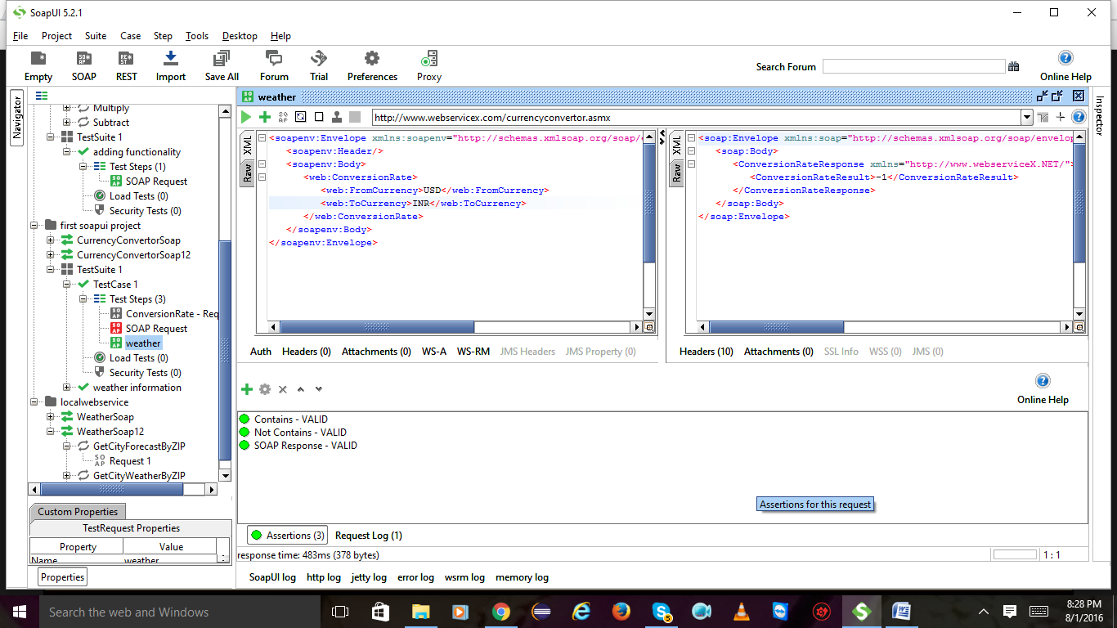

Select Valid http status

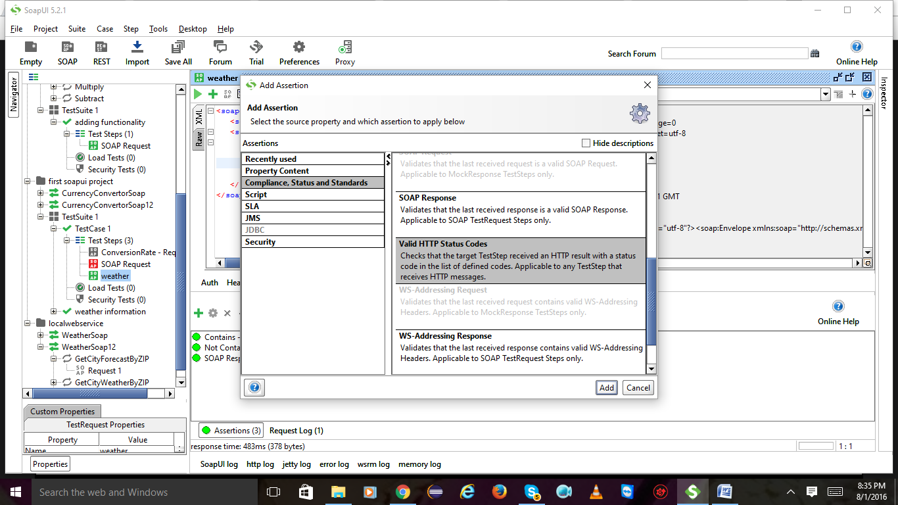

Give 200 as per the raw right side and click on ok

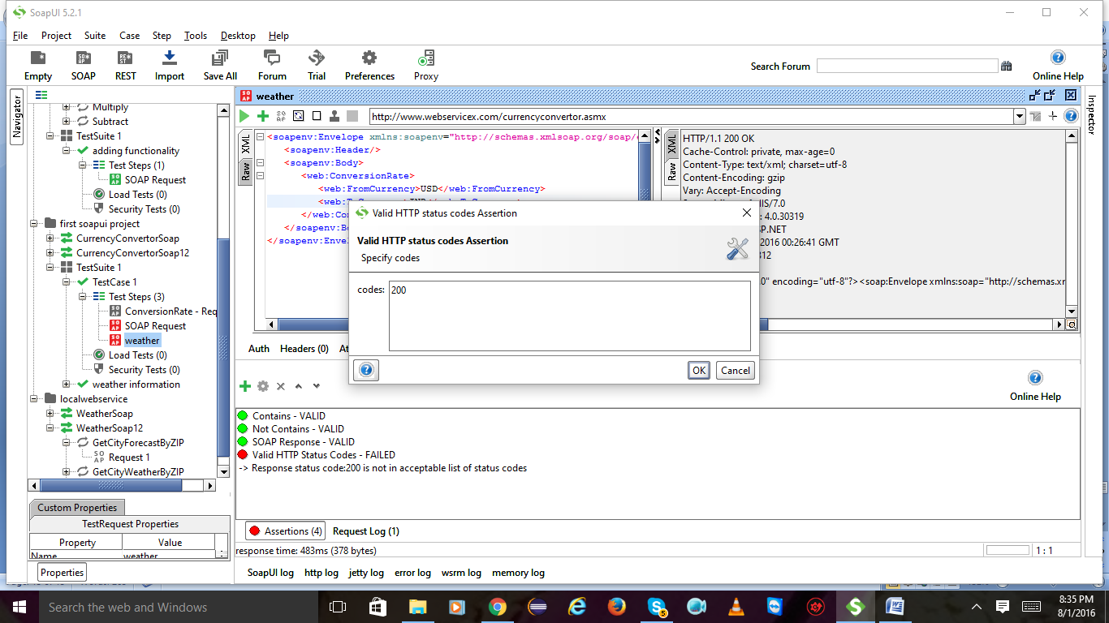

Valid http status codes is valid

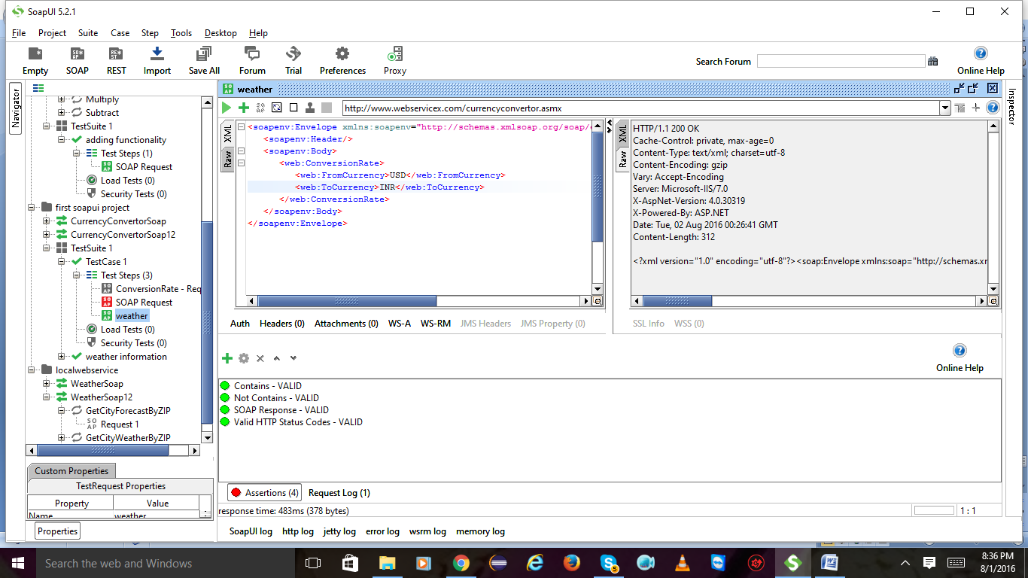

verify that response time is with in boundaries:

add assertion and select SLA in that response SLA click on ok

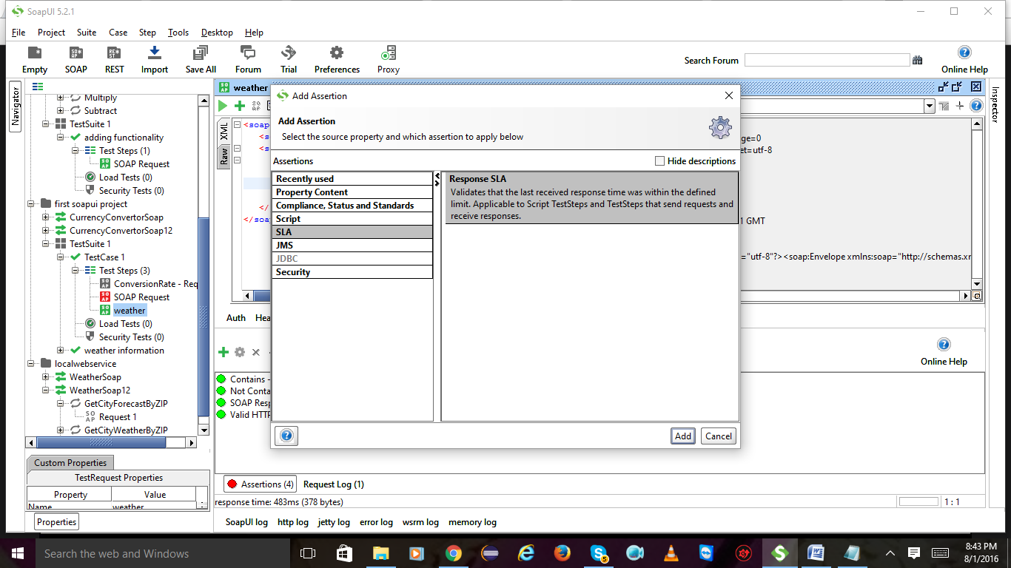

Give whatever millisec it is having

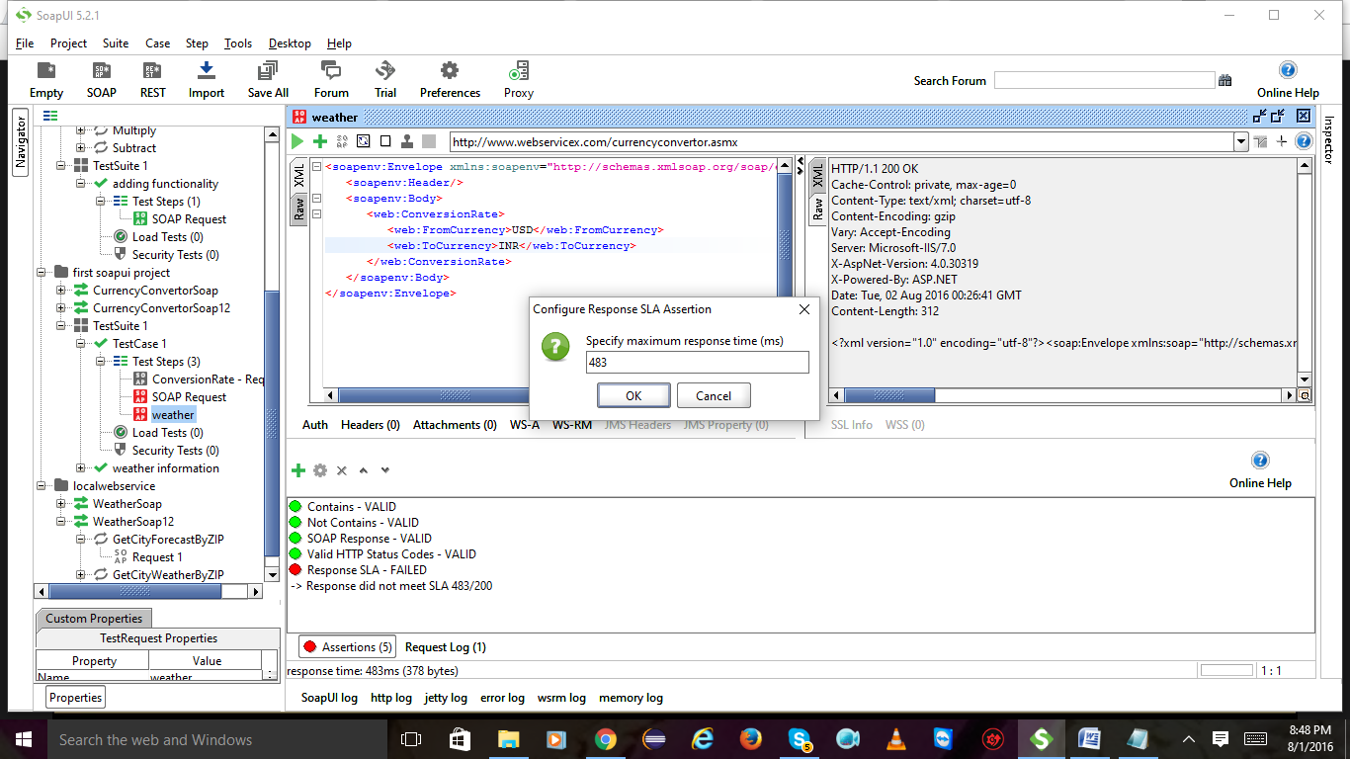

Response SLA is valid

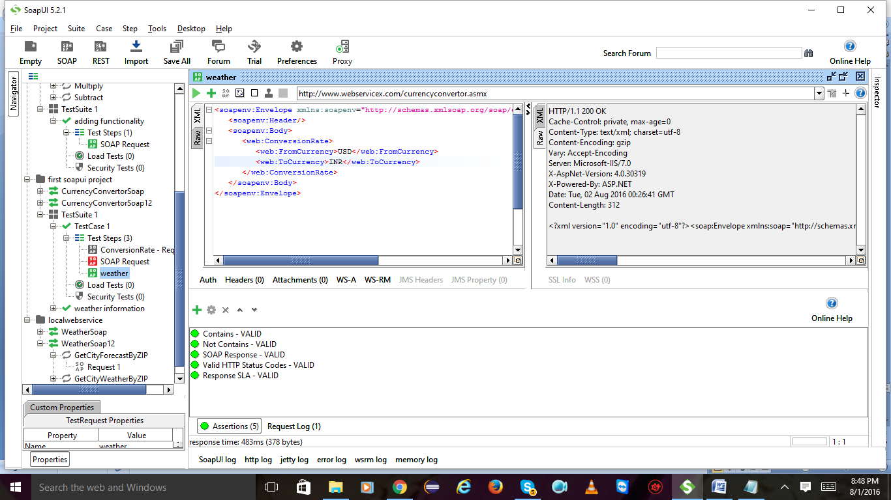

verify security threat

Add assertion select security click on add

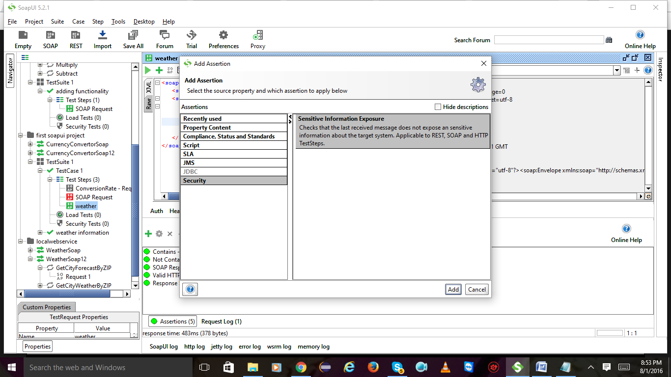

Add assertion here again

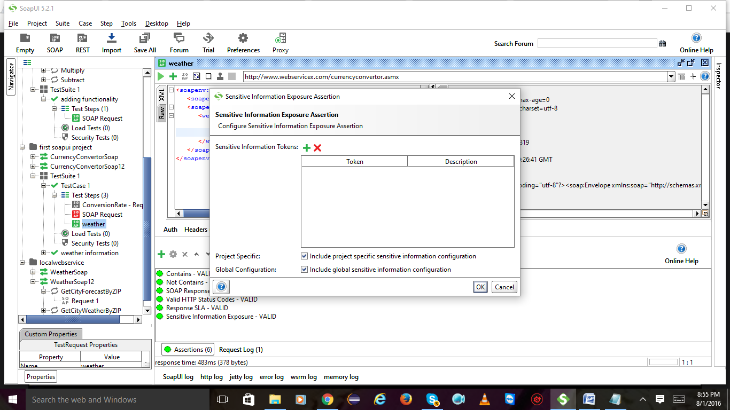

Enter token eg : random and click on ok

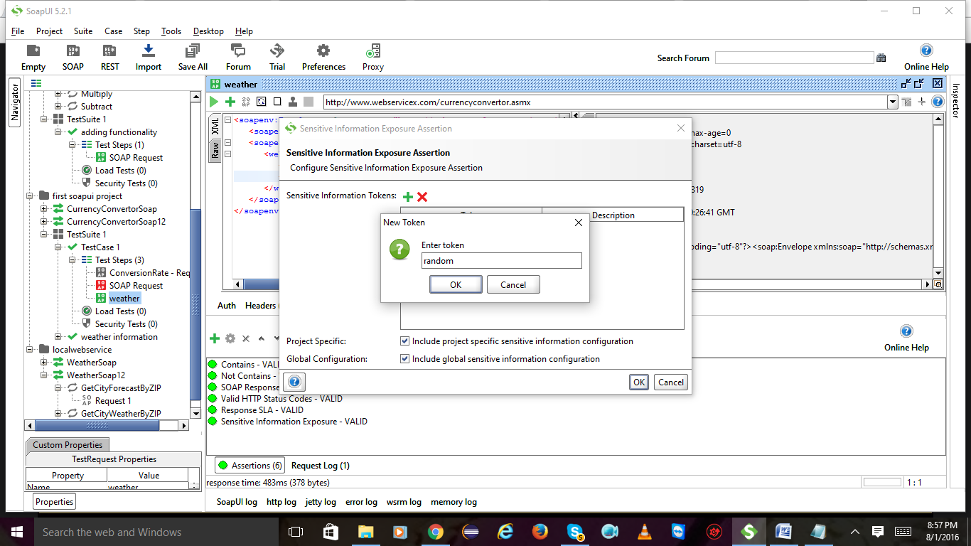

Enter description and click on ok 2 times

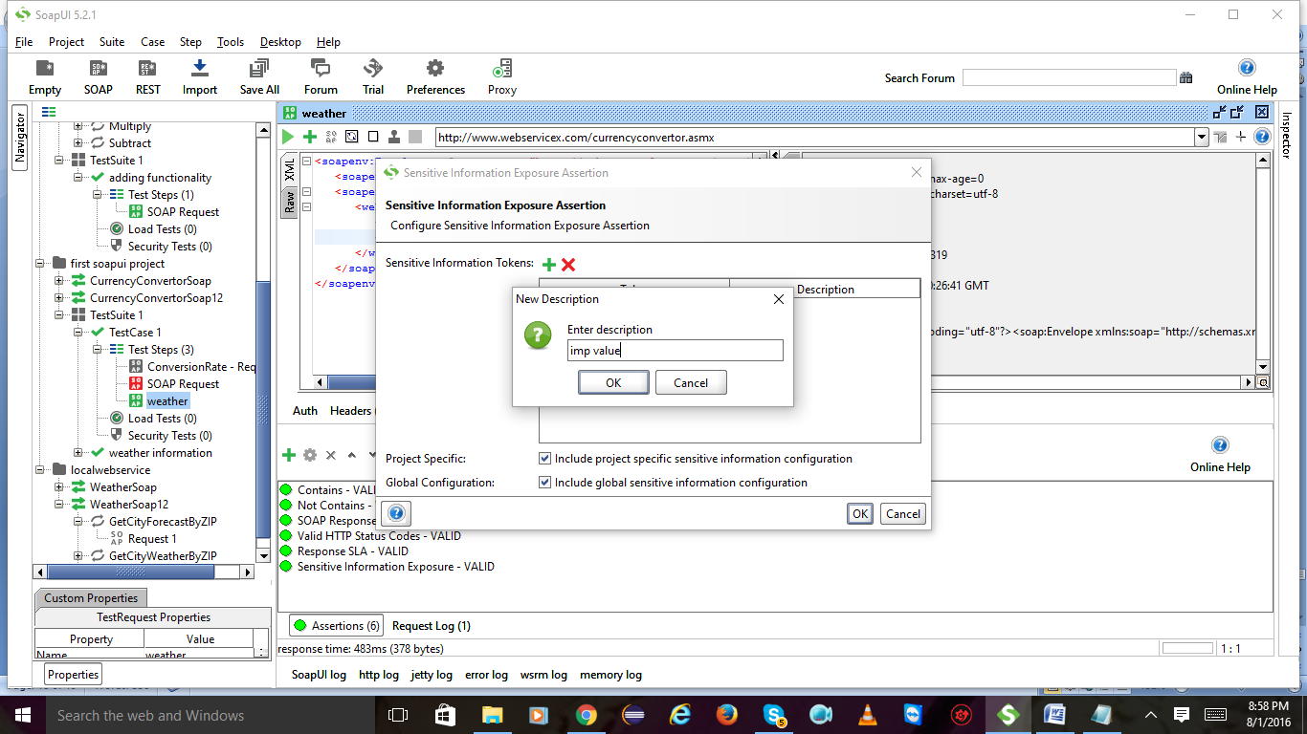

Sensitive information exposure is valid:

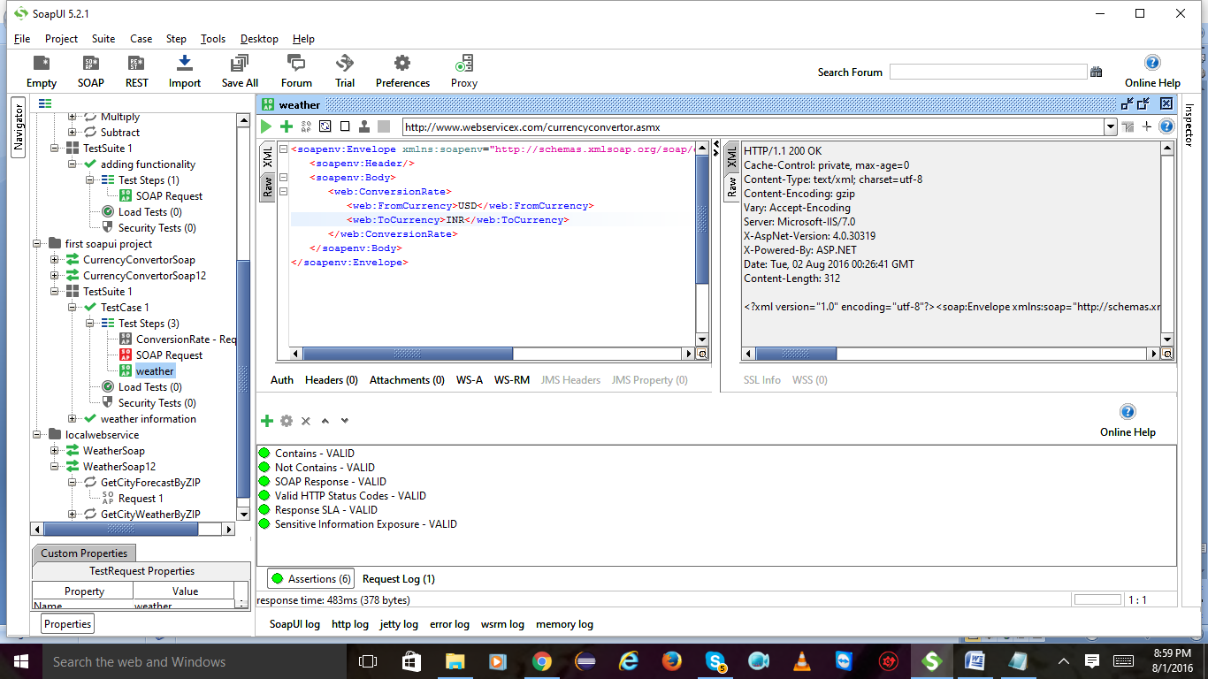

Advanced assertions:

Create a new test case:

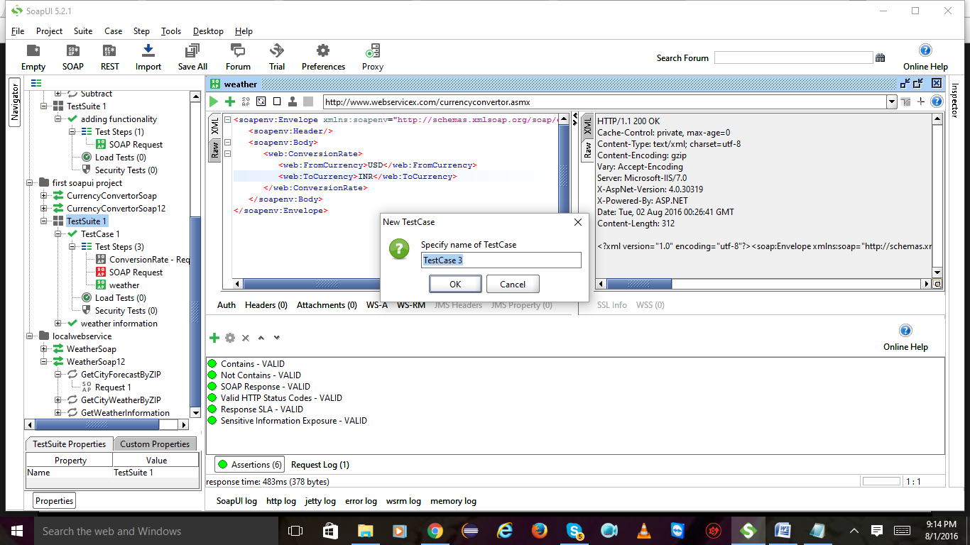

Add step and select soap request

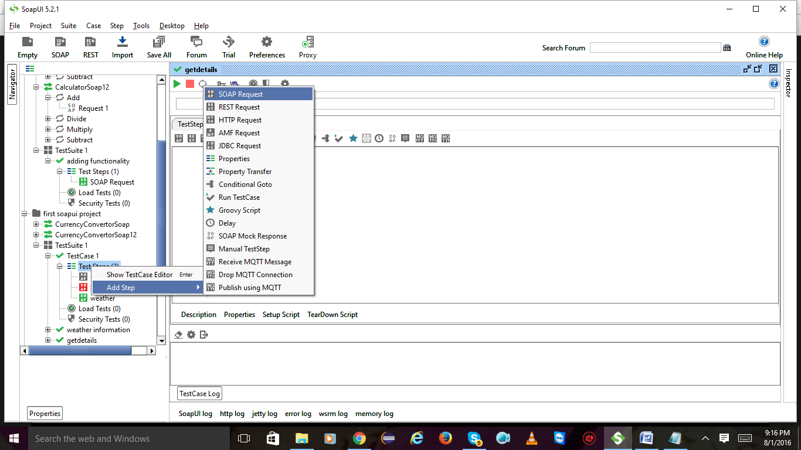

Groovy scripting:

Create a new soapui project

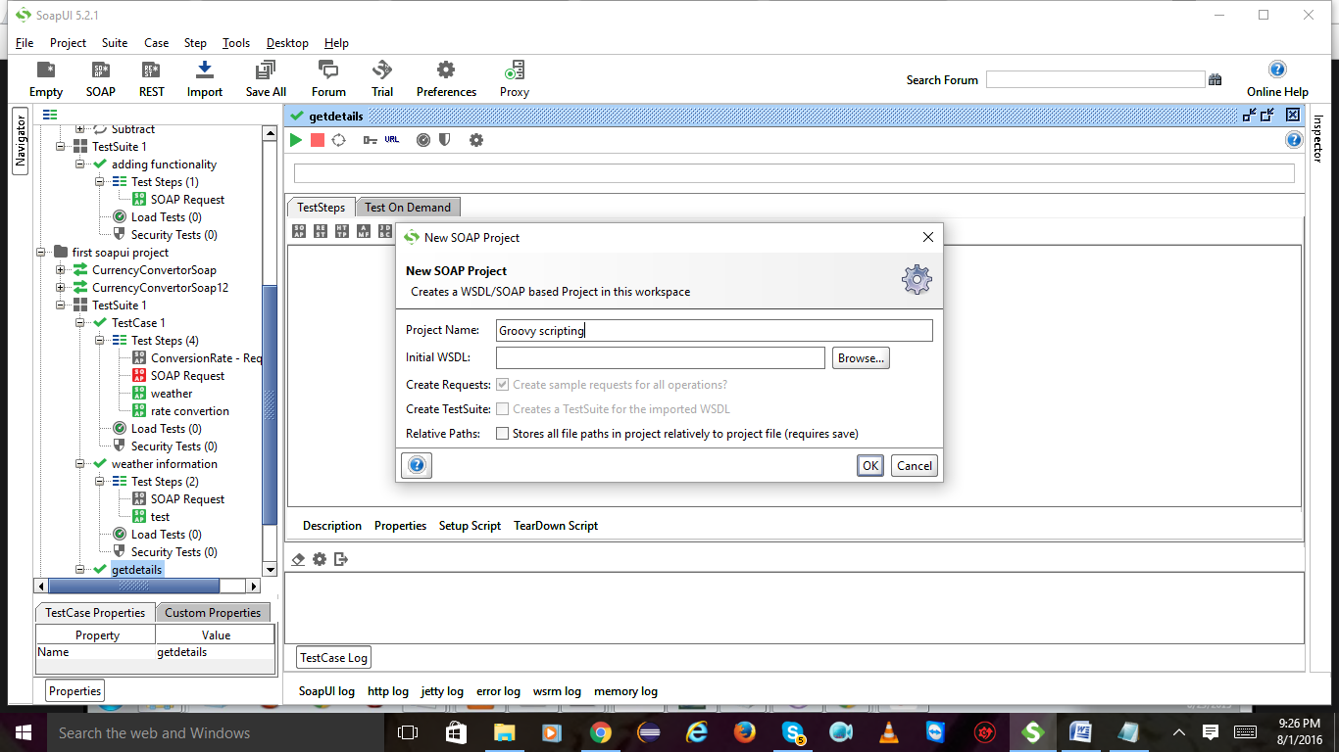

Create a test suite and click on ok

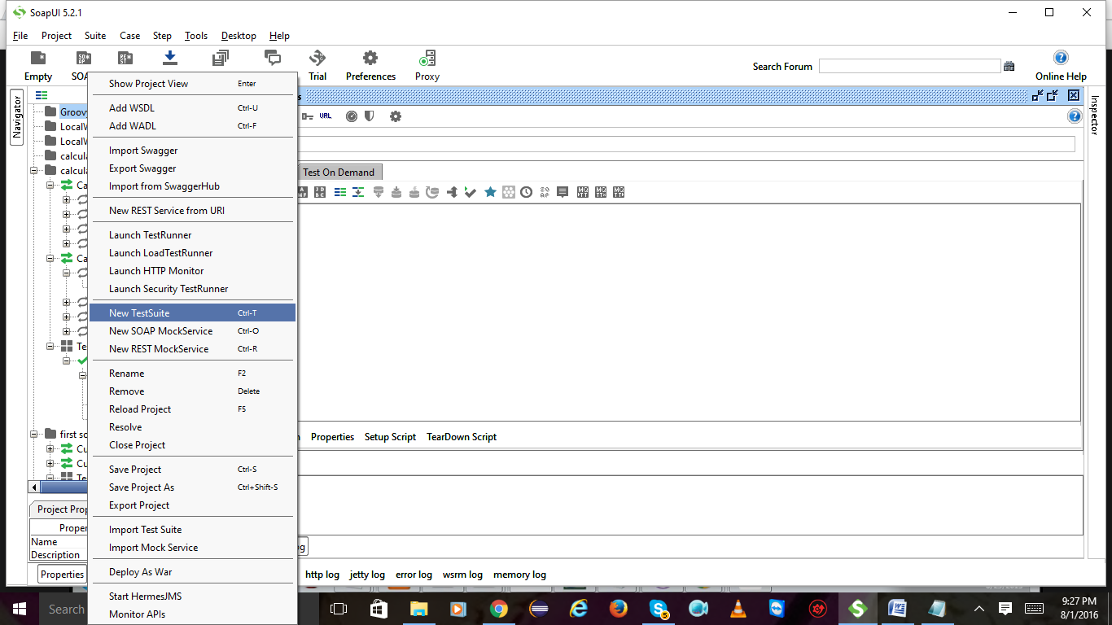

Create a test case

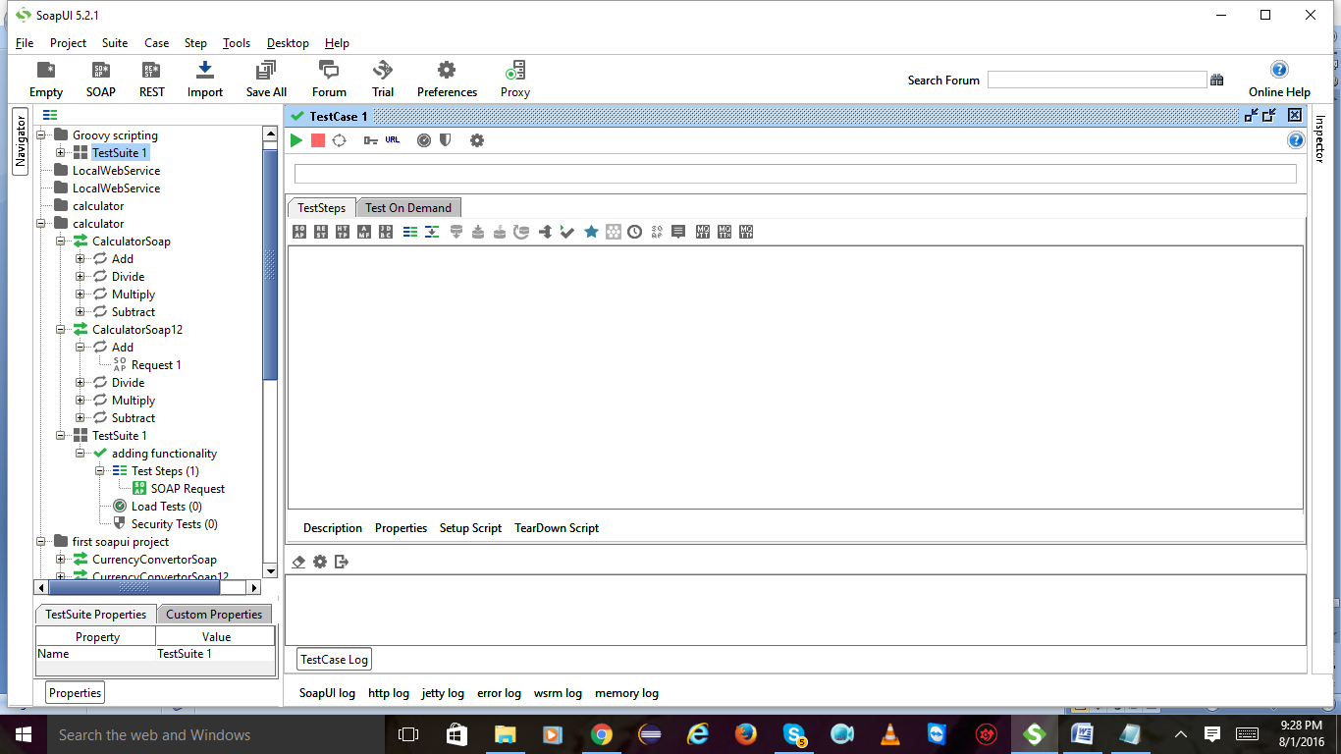

Expand test case Right click on test steps and select add step and then groovy script and click on ok

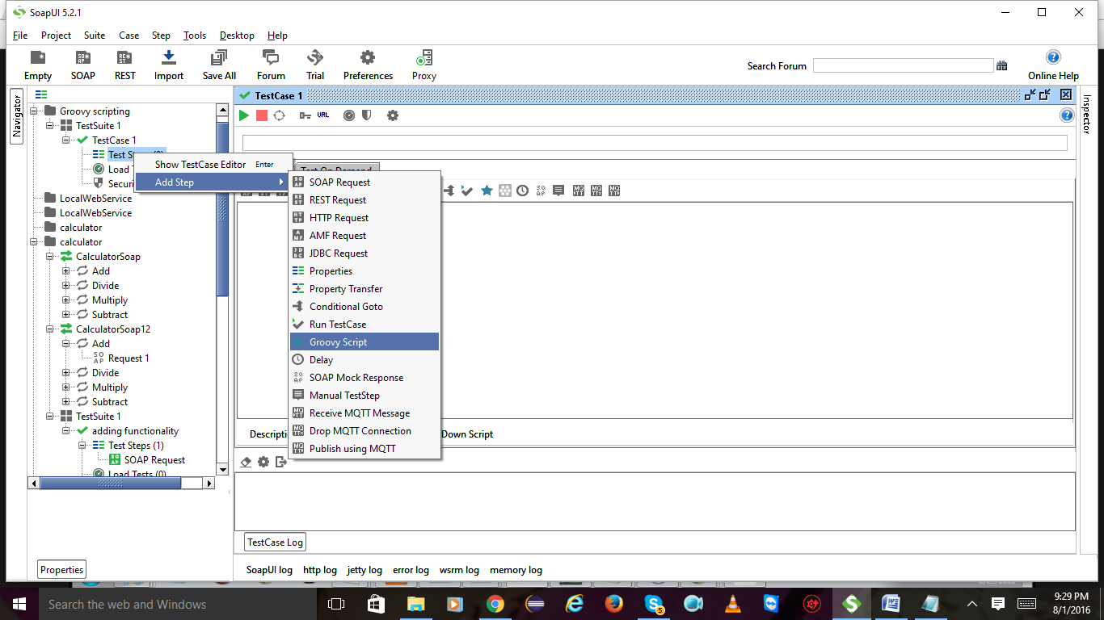

Write a script and hit on play button u will see the result below

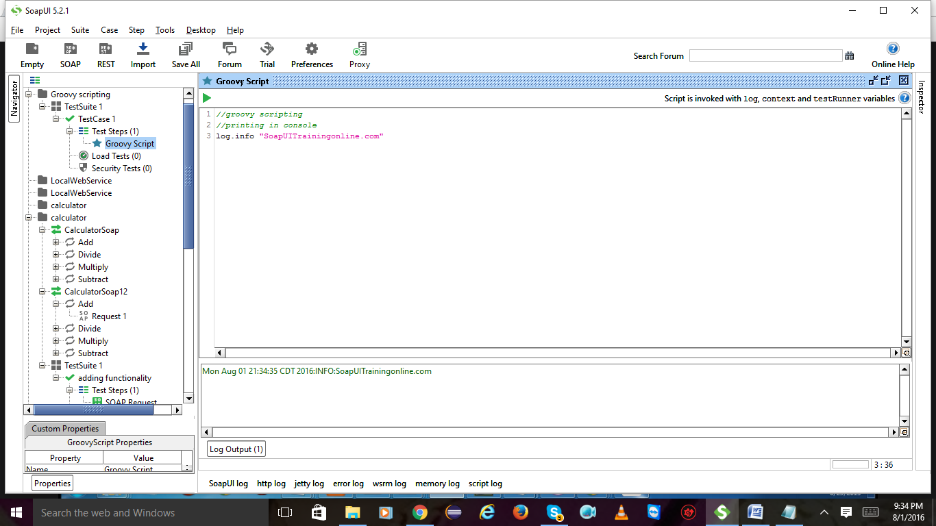

Declaration:

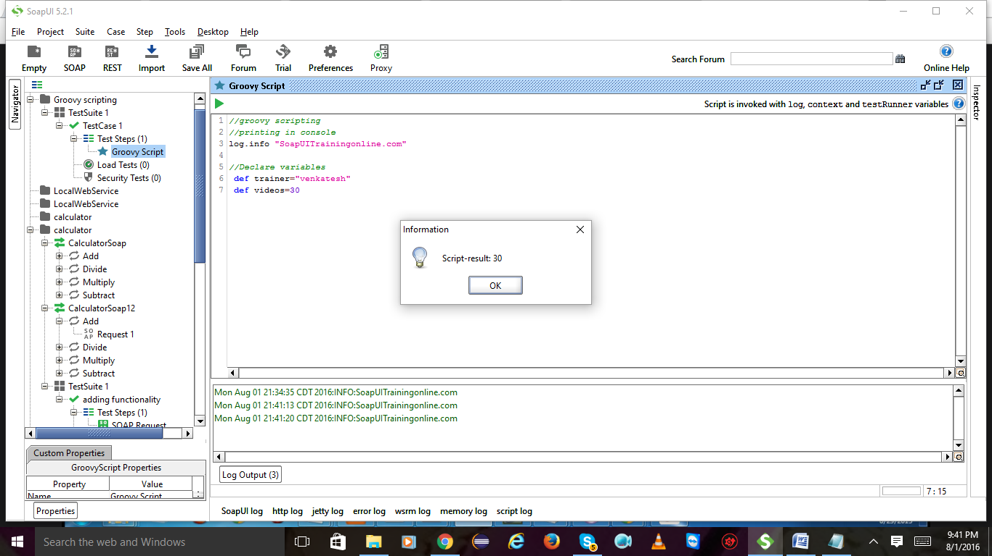

After declaring lets write some code to get the data

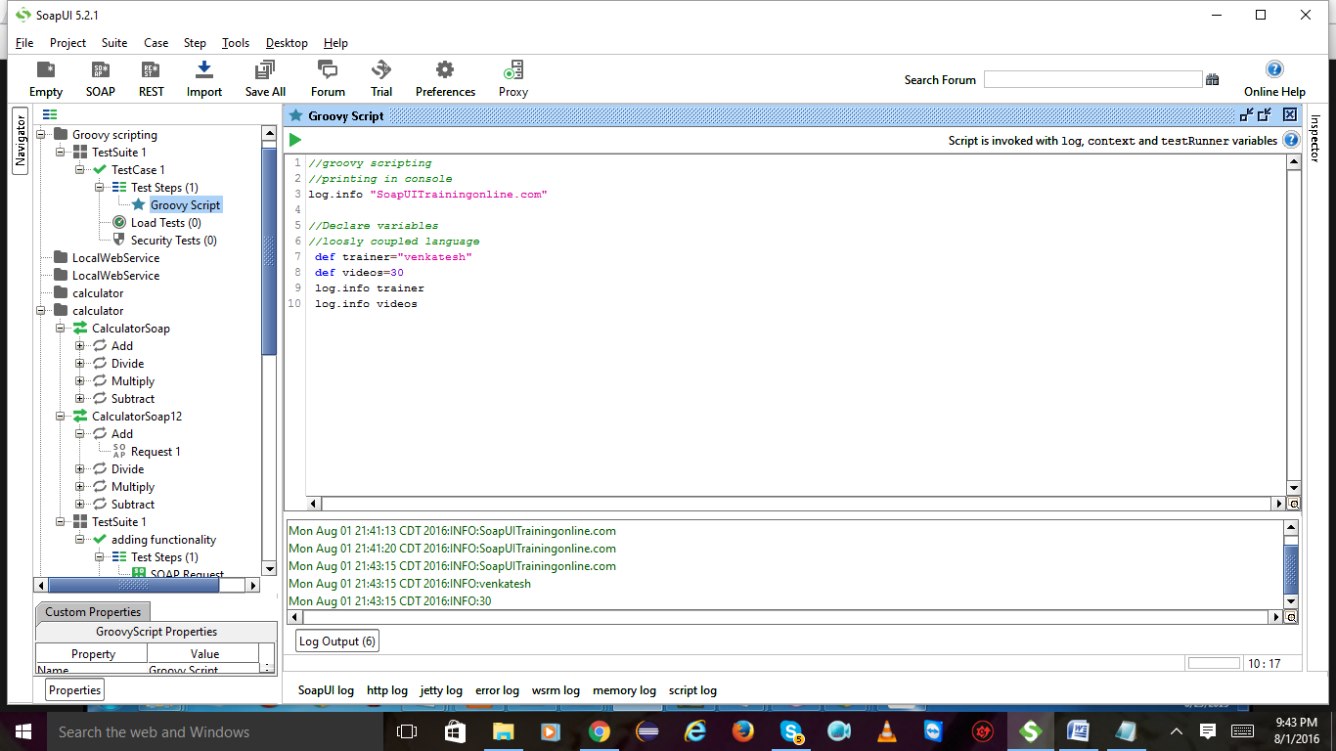

We are concatenating the no of videos

